**Sample #4**

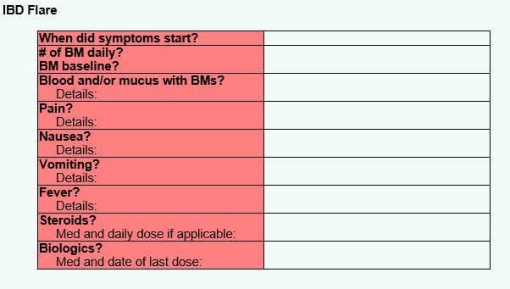

*The nurses have a smart phrase called “.acuteillness” which is a way of pulling up this template into their note to fill out and route to a provider.  They title the note as “urgent patient call” and route it as urgent (which makes a red flag in the chart).  Usually under the template, they can add any additional details they believe are important.*